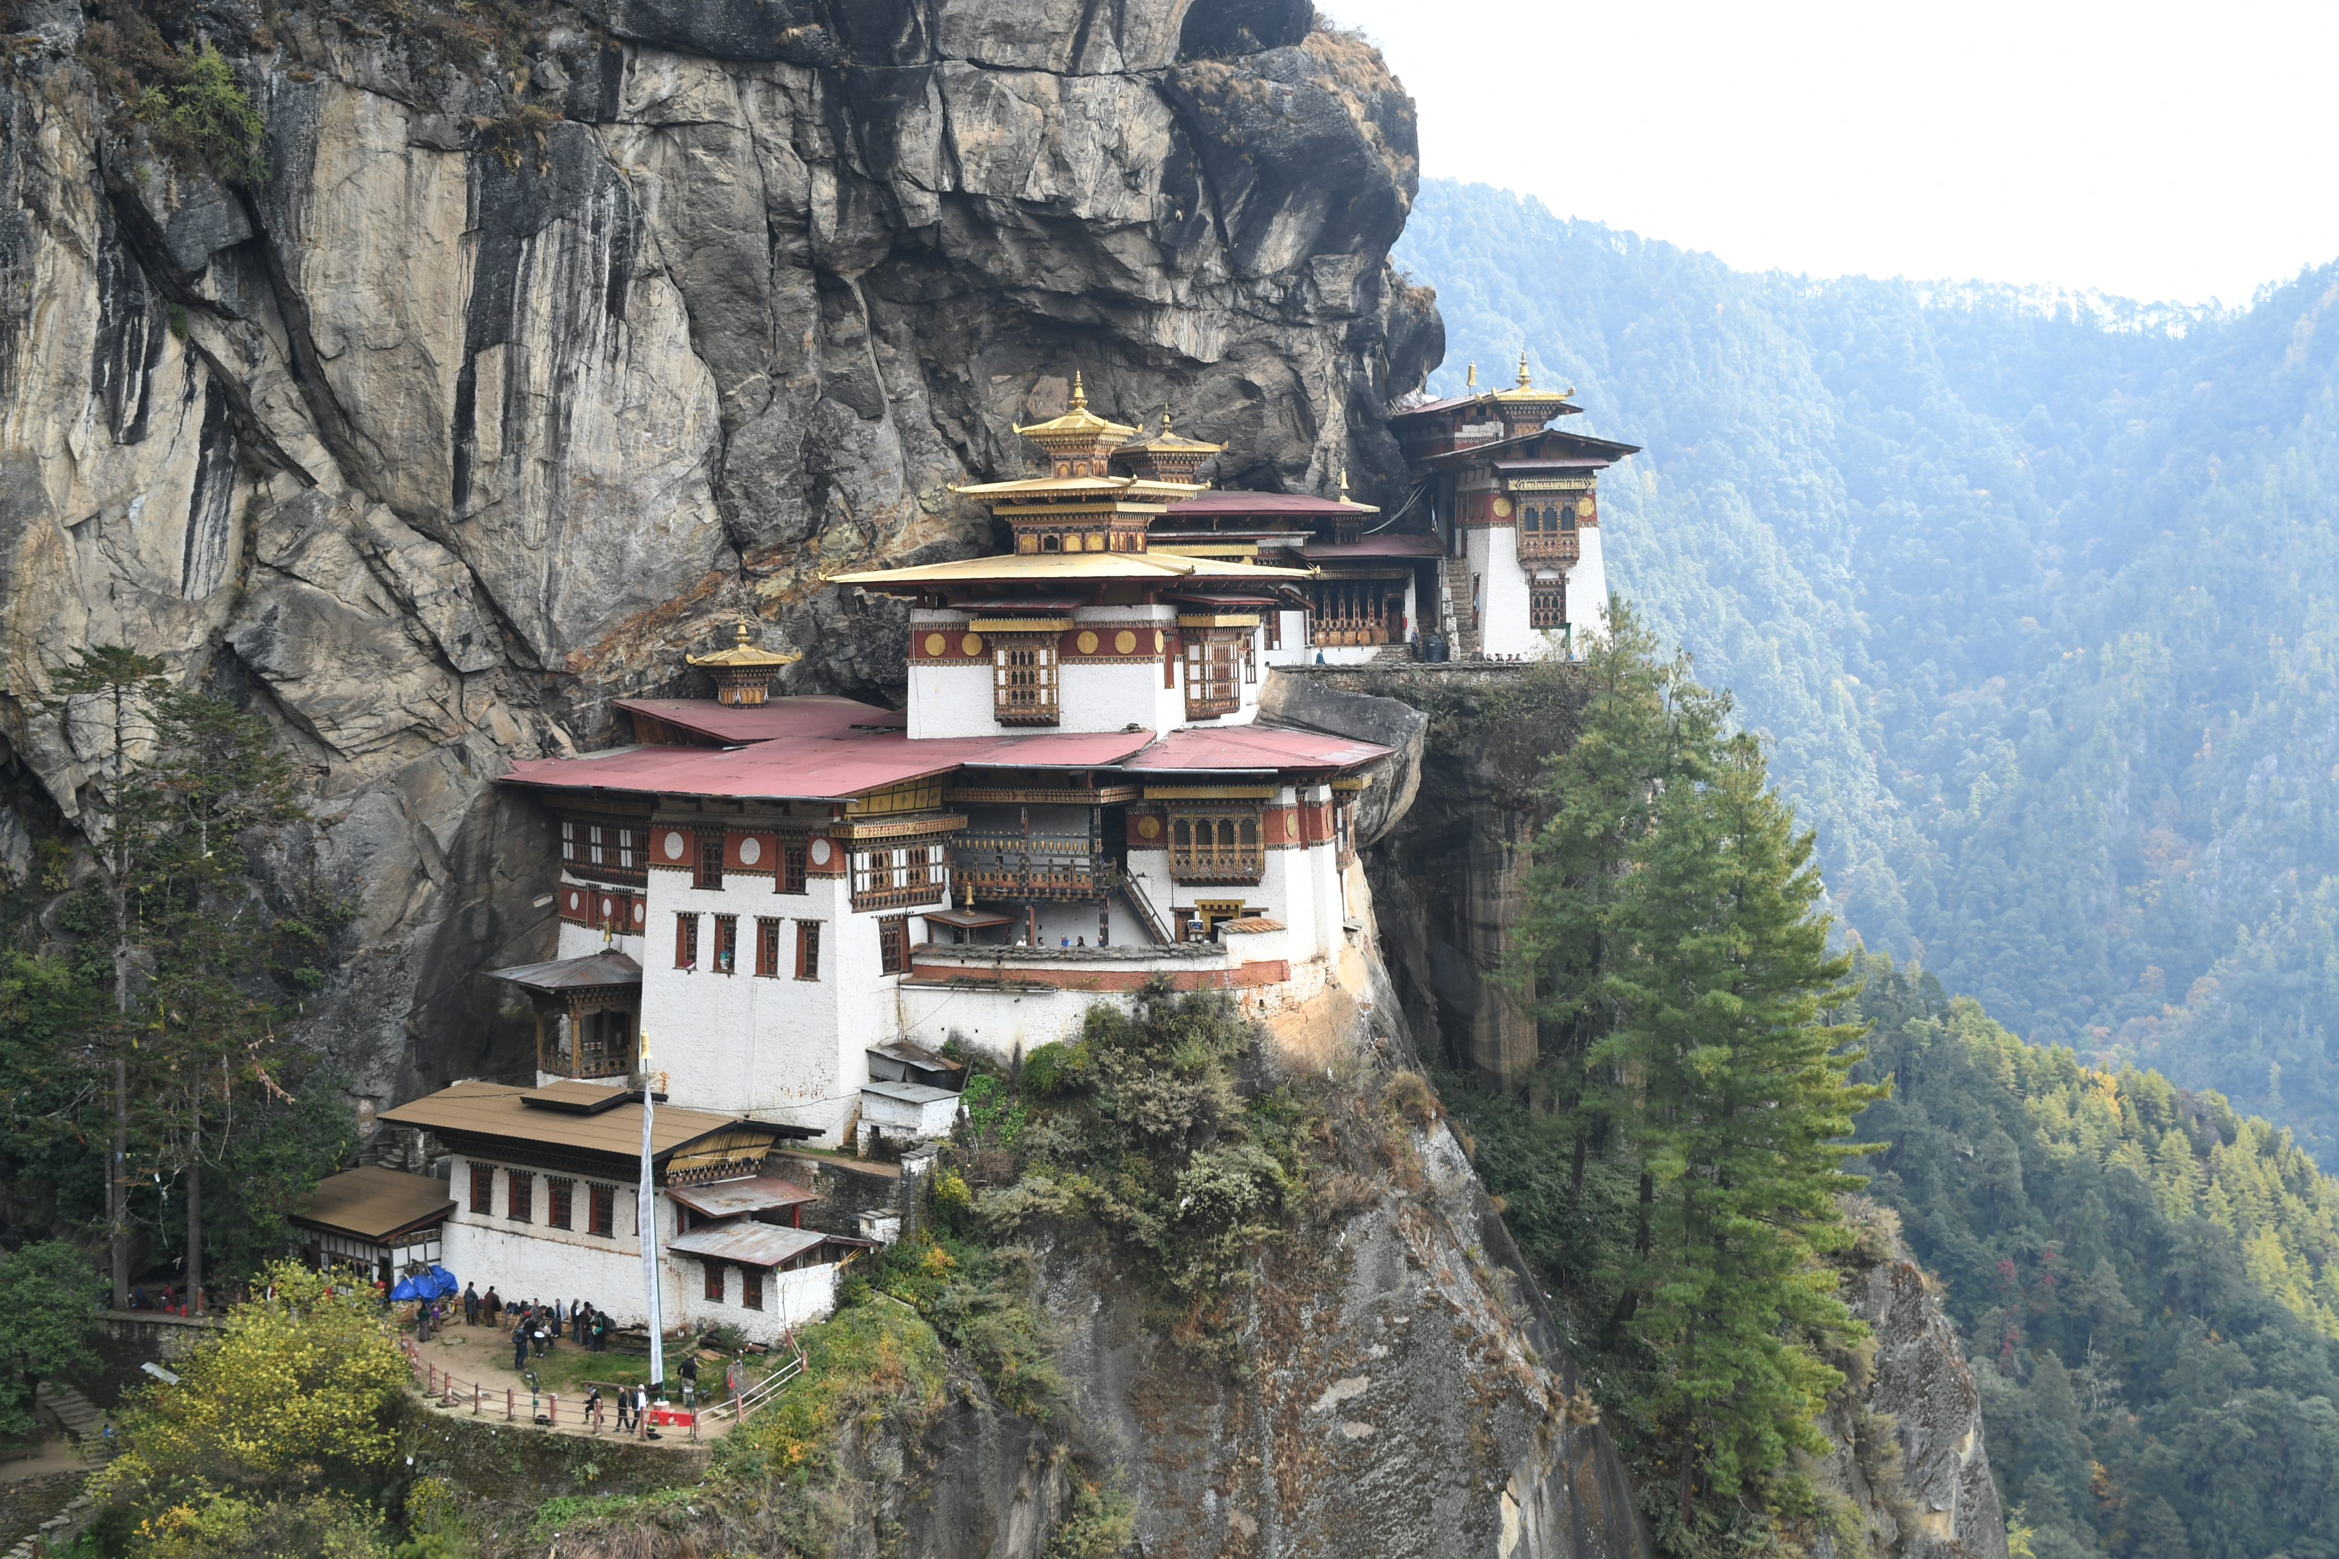
7 DAYS BHUTAN EXPERIENCE
06 Nights/07 Days

Bhutan also known as the Dragon Kingdom is a rich mosaic of different cultures, traditions, life styles, ethnic groups, languages and belief systems. It is astounding that a country with a population of just over half a million speaks as many as nineteen different dialects and a few major languages. Diverse as it may seem, yet the Bhutanese socio-culture fabric is well interlaced and harmonized mainly due to the common thread of simple Buddhist values that the people share. Our cultural tours are the easiest way to get a taste of Bhutan. Each town has a Dzong dating back from the 1600s, and many old temples and monasteries.

Trip dates: December2019
Journey starts and ends in Paro, Bhutan

Day | Program | Accommodation
1 | Arrival in Paro & drive to Thimpu visiting Haa Valley | Hotel in Paro
2 | Full day sightseeing at Thimpu | Hotel in Paro
3 | Thimpu- Wangdue - Punakha | Hotel in Punakha
4 | Full day tour of Gangtey | Hotel in Punakha
5 | Drive to Paro & Sightseeing | Hotel in Thimpu
6 | In Paro | Hotel in Paro
7 | Departure Transfer

Detailed Itinerary:

Day 1: Arrival in Paro & drive to Thimpu visiting Haa Valley.
The flight in the Himalayas reveals breath-taking views of the great peaks touching into the clouds, taking you right into the Dragon Kingdom's Paro Valley. Our representative will meet you at the airport and transfer you to Thimpu en-route visiting Haa valley.
We will drive eastwards to the pristine and remote Haa valley, which was recently opened to travelers. The valley is dotted with fields of millet, barley, and potatoes and full of ancient shrines. Haa Valley is the western most state in Bhutan. It borders the Indian state of Sikkim and Tibet. On a clear day there are superb views from the pass of two of Bhutan's highest and best-known peaks -- Mount Chomolhari and Jitchu Drake. We will stop here briefly to enjoy the lovely mountain scenery and then continue down to Haa town (2,670m / 8,811ft). Spend the day exploring the Haa Valley. Visit two famous monasteries, Lhakhang Karpo (White Temple) and Lhakhang Nagpo (Black Temple).
Overnight at Hotel in Thimpu [-/-/D]
Day 2: Full day sightseeing tour of Thimpu.
After breakfast we will visit Memorial Chorten, the National library of Bhutan, Folk Heritage Museum and Tashichho Dzong.
The Memorial Chorten, also known as the Thimphu Chorten is a large Tibetan-style Buddhist Monastery with golden spires and bells. It is a popular landmark and one of the most visible religious structures in Thimphu.
It was built in 1974 to honor the memory of the third king, Jigme Dorji Wangchuck. The chorten is richly carved and contains statues and a shrine dedicated to the king. The king’s photo in a ceremonial dress adorns a hall in the ground floor. The king when alive wanted to build ‘a chorten to represent the mind of the Buddha’.
The National Library of Bhutan is a four-storied eight-cornered traditional building, which looks like the central tower temple of a Bhutanese Dzong. It was initially housed and established in 1967 within the central tower of Tashichho Dzong. Later, due to its growing collection, it was moved to its current location and inaugurated in 1984. The building that initially had a small collection of precious texts now holds an archive responsible for collecting and preserving important past, present and future documents on Bhutan for future generations. The library also has a representative collection of English and western language books mainly related to the Himalayas, Bhutan and Buddhism.
The Folk Heritage Museum is set inside a 19th century three-storied traditional building and was established in 2001. The museum houses different tools, materials, objects, equipment and artifacts from rural Bhutanese households and gives a good insight of the traditional Bhutanese lifestyle.
To showcase the authenticity of the country, the museum preserves a rural setting with paddy, wheat and millet fields, a traditional water-mill with mill stones more than 150 years old, traditional style kitchen gardens with vegetables that were grown over the past 100 years and the famous traditional hot stone bath. Native trees and plants that had domestic uses in Bhutanese rural household are being grown here in an effort to keep indigenous knowledge about the use of natural resources alive.
Visit the Tashichho dzong. This dzong is an impressive building also known as ‘the fortress of the Dharma Raja’. It has traditionally been the seat of the Druk Desi, the head of the Bhutan’s civil government.
The dzong has suffered several damages in the past. The original dzong was destroyed in the 1771 fire and again twice since then. Later the dzong was damaged in an earthquake in 1897 and was rebuilt in 1902. When King Jigme Dorji Wangchuck moved his capital to Thimphu in 1952, he started a five-year project that completely redesigned, enlarged and redesigned the dzong without using any nails or written plans.
Overnight at Hotel in Thimpu [-/-/D]

Day 3: Thimpu – Wangdue - Punakha (90 KMS/ Approx. 3.5 hours)
After breakfast enjoy drive to Wangdue. En-route we will stop at Dochula Pass (3150 m), 30 km from Thimphu, for tea and biscuits and enjoy a view of the Eastern Himalayan Mountains. From Dochula to Wangdue, it's another two hours’ drive. Wangdue Phodrang Dzong is perched on a spur at the confluence of 02 rivers. The position of the Dzong is remarkable as it completely covers the spur and commands an impressive view over both the north-south and east-west roads. The main road climbs the length of the spur and on the left, across the river, comes the first glimpse of the picturesque village of Rinchengang whose inhabitants are celebrated stonemasons. After lunch in Lobesa, visit the Punakha Dzong. This is the winter residence of Bhutan's spiritual leader, the Head Abbot, and the Central Monastic Body. The Dzong is built between two rivers known as "Phochu" (Male River) and "Mochu" (Female River).
Upon arrival at Punakha check in to hotel and enjoy rest of the day at leisure.
Overnight at Hotel in Punakha [B/L/D]

Day 4: Full day Tour of Gangtey
Today we will proceed for full day tour of Gangtey monastery and pastureland & return to Punakha. Views of wide yak pasture on the way up and down the pass. Gangtey is a beautiful place situated at an altitude of 3000m. From Gangtey, one can closely view the picturesque black mountain ranges as well as the beautiful Phobjikha valley which is one of the biggest and the most beautiful valleys in the country. During winters, we can also see the famous Black Necked Cranes there. Afterwards, drive back to Punakaha.
Overnight at Hotel in Punakha [B/L/D]

Day 5: Drive to Paro & sightseeing
After breakfast we will drive back to Paro. Upon arrival visit The National Museum of Bhutan, Paro Dzong and Kyichu Monastery.

Visit the National Museum of Bhutan, a unique circular building also known as Ta-dzong which is an ancient watchtower above the Paro Dzong. This unusual round building is said to be in the shape of a conch shell. The original building was constructed in 1656 but the building was converted into a museum in 1968.
The building houses some of the finest specimens of Bhutanese art, including masterpieces of bronze statues and paintings gathered from different parts of the country with cultural heritage of more than 1500 years. The National Museum has in its possession over 3,000 works of Bhutanese art, rich holdings of various creative traditions and disciplines that represent a remarkable blend of the past with the present.
Visit Paro Dzong, also known as Ringpung Dzong means ‘Fortress on a heap of jewels’. This impressive dzong is the finest example of Bhutanese architecture and is one of the most popular and well known dzongs in Bhutan. It is the administrative seat of the district of Paro. The dzong was built in the 16th century on the foundation of a monastery built by Guru Rinpoche. In the past, this dzong was used on numerous occasions to defend the Paro Valley from invasions by Tibet.
Unlike most of the other dzongs in Bhutan that suffered severe damage, the Paro Dzong survived the massive earthquake of 1897. However, it was almost burnt to the ground by a fire in 1907. All-important relics were lost to the fire and nothing could be salvaged except for the Thongdrol, a 20x20 meter-wide Thangka. The Thangka is displayed annually during a ceremony called Paro Tshechu. The Dzong was however rebuilt the following year.
Later visit the Kyichu monastery. Located close to the Paro Airport, the Kyichu Lhakhang is an important Himalayan Buddhist Temple. Built in the 7th century, this is one of Bhutan’s oldest religious sites in Bhutan. The temple is one of 108 built by Tibetan emperor Songtsen Gampo to subdue a demoness who prevented the spread of Buddhism. Temples were built across the Himalayas to pin her body down. Kyichu Lhakhang pins down her left foot and Jamba Lhakhang in Bumthang her left knee.
Guru Rimpoche visited this temple in the 8th century and concealed many spiritual treasures here. The fine statues of the Bodhisattvas and the Buddha in this temple are national treasures. The wooden floor of the sanctum is inlaid with turquoise and coral gemstones offered by pilgrims.
Overnight at Hotel in Paro [B/L/D]
Day 6: In Paro
After early breakfast enjoy the excursion of Taktsang Monastery with a short trek through monastery about 10Km from Paro town. Evening enjoy farewell dinner.
Perched on the side of a vertical cliff at 3000 m altitude north of Paro, the beautiful Taktsang Monastery also known the ‘Tiger’s Nest’ is the most famous and an unofficial symbol of Bhutan. Legend has it that Guru Rinpoche (Guru Padmasambhava) flew to this location from Khenpajong, Tibet on the back of a tigress and subdued a demon. He then meditated in a cave here for three months and emerged in eight incarnated forms (manifestations) and blessed the place. Guru Padmasambhava is known for introducing Buddhism to Bhutan. Today, Paro Taktsang is the best known of the thirteen caves in which Guru Padmasambhava meditated.

Taktsang Monastery is a pilgrimage site for both tourists and locals. The journey up to the monastery is filled with spiritual bliss. Keeping this spiritual side aside, the journey up to Taktsang Monastery is also a hiker’s delight. An hour hikes up to a small wooden teahouse called Cafeteria provides close view of the monastery. A further and a rather challenging hike lead you to the glorious Taktsang Monastery.

Transfer back to Hotel for rest. After refreshments, receive for farewell dinner at selected local restaurant at Paro.
Overnight at Hotel in Paro
Day 07: Departure Transfer
Today you will be transferred to Paro airport for your onward flight.

==========================TOUR ENDS=======================================
Note: All information in this itinerary is accurate to the best of our knowledge but please note that changes to our trips can and do occur. This may be due to our effort to improve our program or logistical reasons such as changes in flight schedules, traffic conditions, weather conditions, or government policies. Luxury DMC will make every effort to keep you informed of any changes but cannot be held liable for any alterations made to the published itinerary.
Please be informed that there is road expansion process in all the cities of Bhutan and will be in a process for about couple of year, hence the transfers and tours might take more time than mentioned in the itinerary. Therefore, it is requested to start the program as early as possible in order to avoid any kind of delay.

The Nett land cost in US$ per person on twin sharing basis:
Group Size | Cost per person
1pax to 16 pax | US$ 1500 per person)
Single room supplement | US$ 35.00
*Please note that increase/decrease in group size will change the cost accordingly.

Hotels used:
City | Hotel Used | Room Category | No of nights
Thimpu |  | Standard Room | 0 Nights
Paro |  | Standard Room | 0 Nights
Punakha |  | Standard Room | 0 Nights

The above cost includes:
Cost includes:
-Government royalty and all the taxes
-FIT Surcharge for one and two persons (i.e 40$ & 30$)
-Accommodations on twin sharing basis
-Full time English speaking guide in Bhutan
-Private transportation and sightseeing as per the itinerary
-Museums and parks fees indicated in the itinerary in Bhutan
-Mineral water in transfer.

Cost Exclude
- Air fare
-Any alcoholic, nonalcoholic beverages and any other personal expenses
-Tips to guide, driver, trekking staff, hotel service, etc
-Travel Insurance
-Single room supplement charges ($ 35/-) for 3 Star Hotel.

